

AC Joint Sprain
Dr. Abigail Hamilton, MD

Anatomy of the AC Joint

The AC joint is short for the Acromioclavicular Joint. It is made up by three ligaments in total. One ligament that connects the end of your clavicle and the acromion, the acromioclavicular ligament. Then there are two ligaments attached to the coracoid process, Coracoacromial ligament, which connects to the acromion, and the Coracoclavicular ligament, which is made up of two parts, that attaches to the clavicle. These three ligaments help hold the AC joint into the appropriate position.

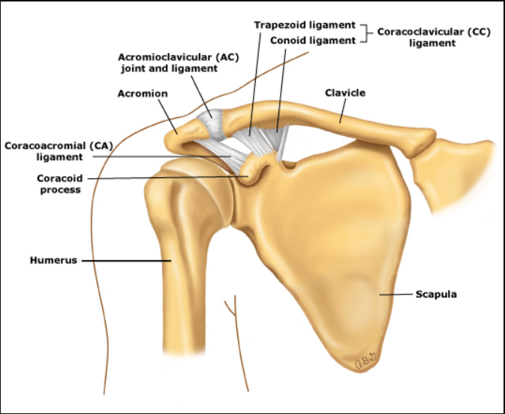

Degrees of AC Joint Sprain

There are five degrees of AC Joint sprains. The first three degrees of sprains are normally treated non operatively with oral NDAIS, Tylenol, Ice, activity modification and physical therapy. The first and second degrees will progress more quickly than the third and feel better faster compared to the third degrees sprains. The fourth and fifth degrees are treated surgically if appropriate for the patient’s health and activity.

Orthopedic Evaluation:
- After your initial evaluation in the emergency room department, where your shoulder was reduced, you should have close follow up an evaluation to evaluate your injury and determine next steps in your treatment. This may include further imaging with an MRI to asses you rotator cuff and/or labrum for injury. In some instances, surgery may be indicated to help prevent future dislocations.
  - Your first visit should be within 2 weeks.
  - You should follow up every 4-6 weeks as directed by your physician.

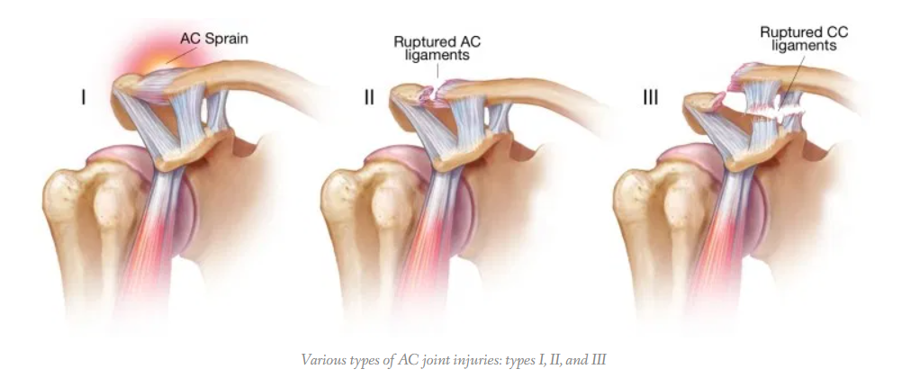

Treatment and Recovery of AC Joint Sprains

Restrictions

Type II and III injuries should avoid heavy (5-10 lbs of weight) lifting, pushing, pulling or contact sports for at least 6 weeks.

Acute phase: 1- 14 days after injury:

- Type I Injury
  - Ice
  - NSAID’s
  - Shoulder sling for 5-7 days– rest as needed
  - AROM fingers, wrist and elbow o
  - Begin Pendulum Exercises – day 2 or 3
  - Shoulder isometrics trapezius and deltoid muscles
  - Days 7-10 o Expect symptoms to subside
  - Discontinue sling
  - AROM and strengthening as symptoms allow

- Type II Injury
  - Ice
  - NSAID’s
  - Sling as needed for comfort
  - Day 7 Gentle ROM of shoulder
  - Allow use of arm for ADL

- Type III Injury – Non-operative
  - Ice
  - NSAID’s
  - Sling as needed for comfort
  - Leukotape - may increase comfort and facilitate weaning from sling and allow progression of ROM and strengthening exercises.15
  - Begin ADL with arm at 3-4 days
  - Slowly progress functional ROM, gentle PROM at 7 days

Pendulums:
Bend over at the waist and let the arm hang down. Using your body to initiate movement, swing the arm gently forward and backward and in a circular motion.

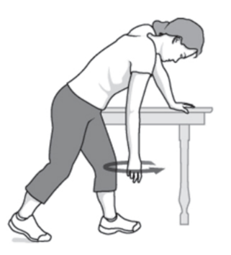

After Acute Stage: Rehabilitation Protocol

Type I and Type II injuries can progress to ROM and strength training as symptoms permit. Type I can return to sport when nearly normal ROM and strength. No heavy lifting, stresses, or contact sports until full painless ROM, and no point tenderness over AC joint (usually by 2-3 weeks).

Type III injuries typically have full ROM at 2-3 weeks with gentle ROM exercises and return to activity in 6-12 weeks with protection of AC joint.

Frequency & Duration:

- Type I or II
  - 1-2 times per week for 2-6 weeks
- Type III (Non operative)
  - 1-2 times per week for 4-12 weeks

Progression through Physical Therapy

- PROM, AAROM, AROM progression
- Posture training
- Strengthening of trapezius, deltoid, rotator cuff and scapular musculature
  - May include isometrics, exercise bands, active progressing to resistive forward flexion, scaption, side-lying external rotation, seated press-ups, push-ups plus5
- Weightbearing scapular stabilization using physioball
- Joint mobilization if glenohumeral joint limitations; contraindicated at AC joint if hypermobility.
- Protection of the AC joint with padding if patient will return to collision sports, using a “doughnut” from foam or felt. A pad can be used beneath the shoulder padding used in the patient’s sport.
- Modalities as needed– ice, electrical stimulation (refer to each individual practice standard for procedural guidelines.)

Tucson Orthopaedic Institute
East Office
5301 East Grant Road
Tucson, AZ

