

Rehabilitation After Ankle Sprain

Dr. Abigail Hamilton, MD
GENERAL GUIDELINES
Ankle sprains are very common ankle injuries, usually the result of the ankle turning inward. An ankle sprain occurs when a ligament connecting the ankle bones is stretched or torn. If treated quickly and properly, most ankle sprains heal completely, allowing a safe and early return to activity. Recurrent sprains are common, so it is important to strengthen the muscles that stabilize the ankle.
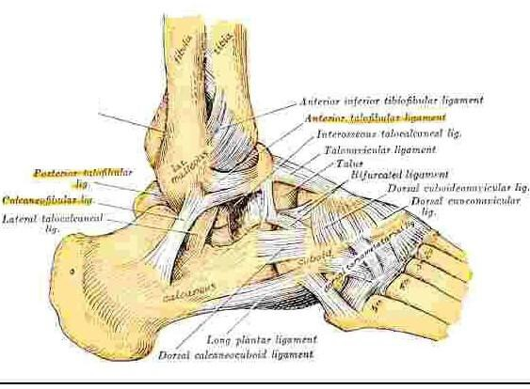
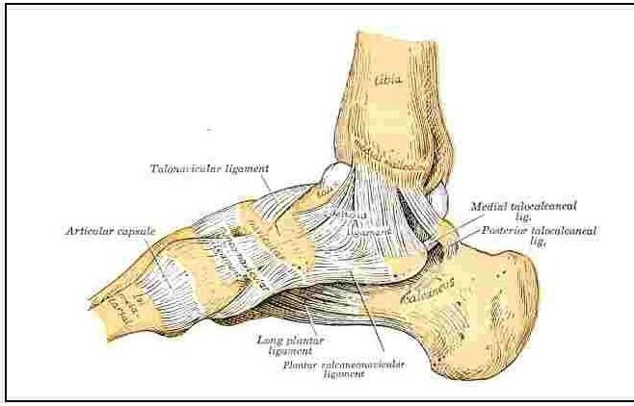

Contributing Factors to Ankle Sprains
- Muscle weakness or imbalance
- Inappropriate footwear
- Overweight
- Family tendency
- High-arch foot
- Previous injury

DEGREES OF SEVERITY OF ANKLE SPRAINS

Ankle sprains are graded as mild, moderate and severe. The more severe the sprain, the longer the time to recover.
First Degree (Mild): This injury is the most common and usually the most minor. Ligaments connecting the bones of the ankle are "stretched'', causing a small amount of injury to the, ankle ligaments. There is slight swelling but no instability. With a first-degree injury, you can expect to be back to sports within 1 to 3 weeks.

Second Degree (Moderate): When this injury occurs, the ankle, ligaments are more deeply torn, resulting more pain and swelling. There is bruising of the skin and pain with walking. There can be looseness and minor instability. A second-degree sprain may require the use of a protective brace and 3 to 6 weeks of rest and recovery before you can return to full activity.
Third Degree (Severe): This injury results in a full tearing or rupture of an ankle ligament(s) usually on the inner and outer side of the ankle. The ankle can be very swollen, and weight-bearing is painful. Crutches are often necessary and sometimes the ankle will be placed in a cast or cast-boot to allow the injury time to rest and heal. Surgery is rarely necessary, but the, third-degree ankle sprain can take many months to fully heal and may result in residual looseness of the ankle joint.

TREATMENT OF ANKLE SPRAINS
Treatment is divided into four stages. The rate of progress from one stage to the next depends upon the amount of pain and swelling present, and whether an elastic bandage, tape, a brace or a cast was used to stabilize your ankle.

STAGE ONE: UP TO 72 HOURS
To reduce pain and swelling, apply ice to the ankle for 20 minutes every hour while awake. Crushed Ice application in a plastic bag with a towel between the ice and your skin is a safe method to use. Compression of the ankle with an elastic bandage will help to limit swelling. The ankle should be elevated, as much as possible, to a position higher than your heart to reduce swelling. Tape, a splint, a brace or a cast may be applied to support or immobilize the ankle.

STAGE 2: THE FIRST WEEK
You can walk and bear weight on the ankle as soon as it is comfortable. Crutches can be used as partial support when you begin to walk. Continue using taping, bracing or a cast. Let pain be your guide as to how much activity is enough
After an injury your ankle will get stiff It is important to maintain the full range of motion of your ankle. As an exercise to increase the ankle motion, rest your heel on the floor and write the alphabet in the air with your big toe, making the letters as large as you can.

STAGE 3: SECOND WEEK AND AFTER
After the pain and swelling have subsided, you should try to walk normally with a brace or elastic support. Maintain ankle motion and strengthen the supporting muscles using TheraBand (elastic bands).

STAGE 4: VARIABLE
Your ankle should be strong when you return to full daily activity or sports. Returning too early to full activity may lead to re-injury and a chronic problem. Criteria to return to sports activity: When you can stand on the toes of the injured ankle for 20 seconds and hop on your toes 10 times you can begin to run. Initially you should jog in a straight line until you jog pain-free. As you become stronger, you can progress to running a large figure-of-eight. You can return to sports practice when you can run a zigzag pattern without pain or instability. Your ankle should be protected with a lace-up or other brace support for a minimum of 6 months after injury for any sport that requires pivoting. A Tri-Lok ankle brace can be obtained from our office for any sports that require quick pivoting and especially are recommended for sports that require the use of cleats, shoes. Athletic shoes that fit well and stabilize your foot will help prevent re-injury. You should not wear running shoes or sandals to play sports such as basketball, volleyball or tennis.

EXERCISES
The following exercises will strengthen the ankle muscles and re-develop the reflexes of the ankle. Following the prescribed exercise program will restore normal ankle function and prevent re-injury and chronic problems.

Ankle Eversion
With tubing anchored around uninvolved foot, slowly turn injured foot outward. Repeat 30 times.
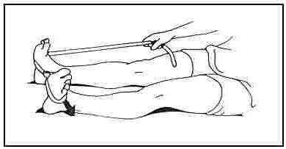

Ankle Inversion
Cross legs with injured ankle underneath with tubing anchored around uninvolved foot, slowly turn injured foot inward. Repeat 30 times.
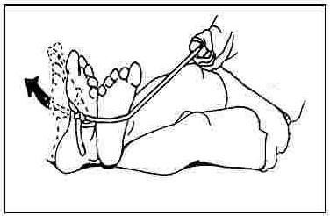

Ankle PlantarFlexion and Ankle Dorsiflexion
With tubing anchored on solid object, pull foot toward you knee. Repeat 30 times.
With tubing around foot, press foot down. Repeat 30 times
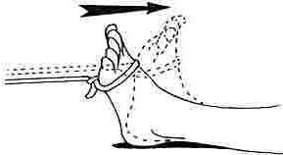

Calf Stretch
Keeping back leg (injured) straight, with the heel and foot flat on the floor, lean into wall until a stretch is felt in the calf
Hold 15 to 20 seconds. Repeat 3 to 5 times, daily.
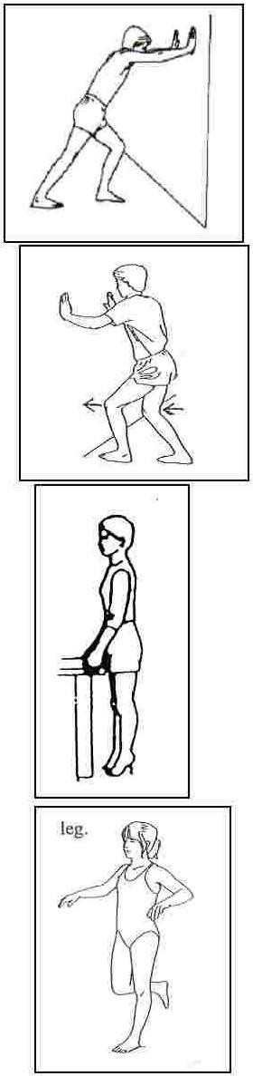

Dorsiflexion Stretch
Standing with both knees bent and the injured foot forward, gently lean forward, bending the injured knee over the ankle while keeping the heel and foot flat on the floor. This stretch will be felt in the ankle close to the heel or in the front of the ankle. Hold 15 to 20 seconds, Repeat 3 to 5 times, daily.

Toe Raises
Stand facing a wall, hands on the wall for support and balance, keep the knees extended fully. Tighten the quadricep to hold the knee fully straight. Raise up on 'tip-toes' while maintaining the knees in full extension. Hold for one second, and then lower slowly to the starting position. Repeat 20 to 30 times. As you become stronger, you can raise up on both legs, and lower down on just the injured side. Gradually build so that you can raise up and down on just the injured leg.

Single -Leg Balancing
Attempt to balance on the injured leg while holding the uninjured foot in the air. When you can balance easily, you can attempt to balance with eyes closed, or while someone throws you a ball. Practice this exercise for 5 minutes.

520-784-6211

Tucson Orthopaedic Institute
East Office
5301 East Grant Road
Tucson, AZ

