
Frozen Shoulder
Dr. Abigail Hamilton

If you are having trouble lifting your arm above your head, reaching across your body or behind your
back, and have limited motion in your shoulder, it may be an early symptom of frozen shoulder.
Chronic idiopathic adhesive capsulitis (Frozen Shoulder) is a condition of the shoulder with several
unusual characteristics:
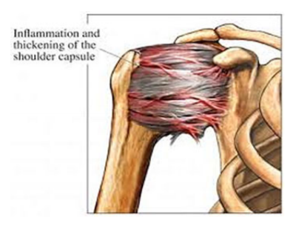

• Its cause is unknown.
• It rarely occurs in otherjoints or parts ofthe body.
• Range of motion is limited globally, that is all planes of
motion are affected by lossof motion.
• It is usually a self-limited syndrome,when
untreated, passing through three distinct phases
of three to four months each: The freezing
phase, the frozen phase and the thawing phase
• In most cases the shoulder and its tissues
recover completely with time, although there
may be some residual restriction in shoulder
motion in some cases.
• It may involve the opposite shoulder, but rarely
recursin the same shoulder.
• X-rays are usually normal
• Frozen shoulder is not associated with arthritis or malignancies.
• Occurs more commonly in women than men.
• Usual onset begins between ages 40 and 65.
• Affects approximately 10% to 20% of diabetics.
• Other predisposing factors include: -A period of enforced immobility, resulting from trauma, overuse injuries or surgery. - Hyperthyroidism. - Cardiovascular disease – Clinical depression.- Parkinson 's disease.

Frozen shoulder develops slowly, and in three stages.

FREEZING PHASE
The freezing phase is a reactive phase. For patients with an acutely and globally painful
shoulder, physical therapy and stretching can cause additional discomfort and stiffening. Resting
from painful activities and analgesics may help with pain control.

FROZEN PHASE
In the frozen phase, the shoulder becomes tighter, the pain becomes less and the patient is more
comfortable. The patient is encouraged to use the shoulder actively and participate in physical therapy
focusing on gentle but frequent stretching exercises.

THAWING PHASE
In this phase, patients report that the motion of the shoulder is gradually returning. The
pain is continuing to decrease. At this time, gentle passive stretching can be increased as
long as motion improves and the stretching does not aggravate the pain.

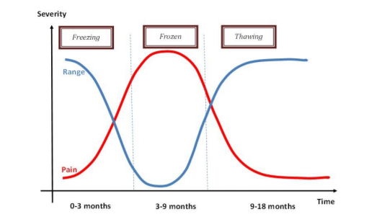
DIAGNOSIS AND TREATMENT

The doctor will test the range of motion in your arm and may ask for an X-ray to rule out
any underlying condition. Treatment is geared to relieving the discomfort and restoring
motion and function to the shoulder.
Treatment includes:
• Medications (such as aspirin, Aleve or ibuprofen) to reduce the, inflammation and
relieve the pain.
• Range of motion exercises
• Heat or ice therapies.
• Corticosteroid (cortisone)injections.
• Range of motion exercises, such as those described below, done several times a day.

RANGE OF MOTION EXERCISES
The following range of motion exercises are usually helpful to keep the shoulder moving and help prevent further tightening. When performing these exercises, do them slowly and hold the arm at the end-point of the range of motion for a few seconds. Release the stretch slowly and repeat. Do not force motion through pain. Follow the instructions for each exercise as described in the illustrations. Usually, the pendulum exercise, tabletop slides and supine neutral external rotation stretches are the easiest to do and the most pain free. After 7 to 10 days, if the shoulder is improving and the exercises do not worsen the pain, the remaining exercises can be gradually added. Add one new exercise every 5 or 6 days in the following order: wall climbing or supine passive forward flexion, internal rotation behind the back, supine external rotation with abduction, and horizontal adduction stretches. As the shoulder motion improves further, you can add the standing external rotation, external rotation in the corner and internal rotation in abduction stretches.

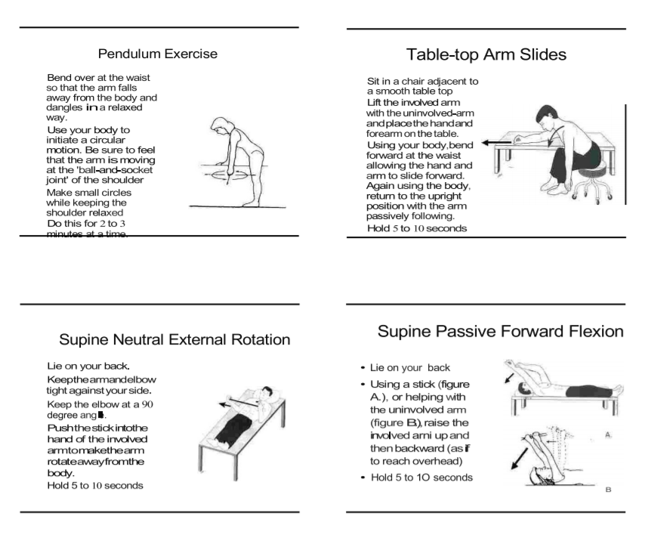

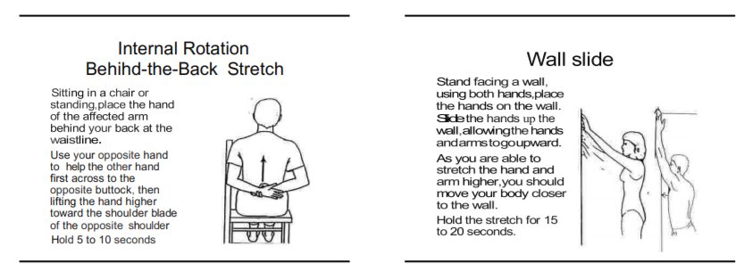

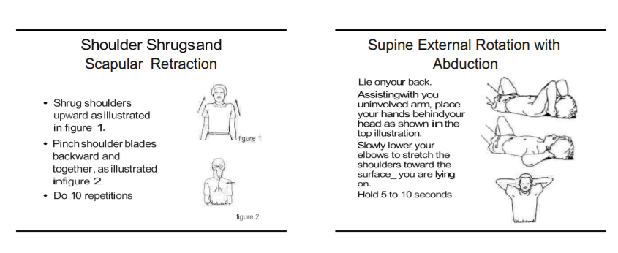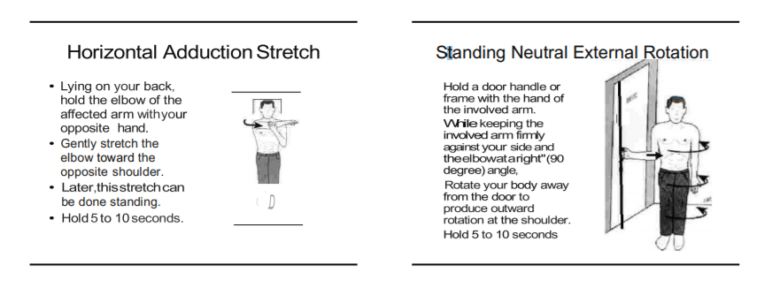
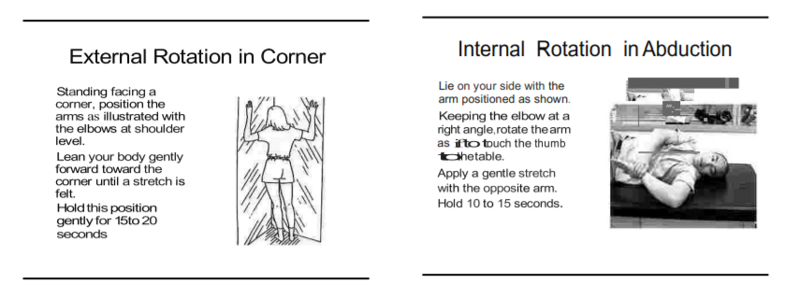

Tucson Orthopaedic Institute
For appointment: 520-784-6211
East Office
5301 East Grant Road
Tucson, AZ

